***Mini-Project Report***

**Function Generator using ICL8038**

*Submitted By*

* **GAURAV CHANDA**

(Roll No.: **34900319030**, Registration No.: **028856 OF 2019 – 20**)

* **KOUSHIK KUMAR ROY**

(Roll No.: **34900319033**, Registration No.: 008932 of 2019 – 2020)

* **HASIBUR RAHMAN**

(Roll No.: **3490**0319039, Registration No.: 008814 of 209 – 20)

* FIROJ HOSSAIN

(Roll No.: **3490**0319028, Registration No.: **009105**  of 2019 – 20)

*Under the Supervision of*

**Prof. Sourav Chakrabarty**

Assistant/Associate Professor

Department of Electronics and Communication Engineering,

Cooch Behar Government Engineering College, Cooch Behar, West Bengal



Department of Electronics and Communication Engineering

**Cooch Behar Government Engineering College,**

Village: Harinchawra, P.O.: Ghughumari,

District: Cooch Behar, West Bengal

June, 2022

**Acknowledgement**

It is our pleasure to acknowledge our supervisor **Prof. Sourav Chakrabarty, Assistant Professor, Department of Electronics and Communication Engineering, Cooch Behar Government Engineering College, Cooch Behar, West Bengal**, for being not only the source of encouragement, but also great resource of knowledge and information. We shall remain indebted to him for the immense help we have received from him.

We would also like to thank all the faculty members, technical assistants and staffs of the Department of Electronics and Communication Engineering, Cooch Behar Government Engineering College, for their kind and friendly cooperation extended to us.

We have no appropriate words to express sincere thanks to our family members for their continuous support and encouragement.

|  |  |
| --- | --- |
| _______Gaurav Chanda___________  **GAURAV CHANDA**  **(Roll no: 34900319030)** | _____Koushik_Kumar_Roy_____________________  KOUSHIk KUMAR ROY  (Roll no: 34900319033) |
| ____Hasibur___Rahman_____________________  HASIBUR RAHMAN  (Roll no: 34900319039) | __Firoj_Hossian__________________  FIROJ HOSSAIN  (Roll no: 34900319028) |

**Abstract**

* The **Function Generator** is defined as a type of device which produces various types of waveforms as its output signals.
* The common waveforms generated by this generator are **sine wave, square wave, triangular wave, and sawtooth waves**. The waveforms of these frequencies may be adjusted from hertz to a hundred kHz.
* A function generator is a piece of electronic test instrument used to test a device under examination and whether electronic equipment is working as intended.
* This paper describes the design of a Function Generator with **ICL8038** by means of **Arduino Nano** and **OP-AMP 741**. The project purposely is used to generate and deliver standard waveforms, typically sine and square waves, to a device under test.
* Utilizes **ICL8038** to generate different kind of standard signals like sine, triangular, square waveforms.
* Using **10k and 1k Potentiometers**, we can change the frequency and the delay time of the signals.
* Using the **OP-AMP 741** we can change the amplitude of the signals.
* Using **Peak-Detector circuit** we turned the signals to DC signal of the maximum voltage (Vmax) of the generating signals.
* Using the **Arduino Nano**, we took the signals frequencies and the DC voltages of the generating signals from the peak-detector circuit as input.
* Using **16X2 LCD display** we display the Amplitudes and the Frequencies of the current input signals as like sine, square and triangular waves.
* By this, we can make the Function-Generator and generate the standard signals like Sine wave, Square wave and the Triangular Wave.

|  |  |  |
| --- | --- | --- |
| **Chapter No** | **Name Of the Chapters** | **Page No** |
| 1 | INTRODUCTION  1.1 Overview  1.2 Motivation | 1-4 |
| 2 | SYSTEM STUDY  2.1 Equipment Description | 4-12 |
| 3 | CIRCUIT DIAGRAM | 13-16 |
| 4 | SYSTEM IMPLEMENTATION | 16-22 |
| 5 | PROGRAMMING CODE | 22-25 |
| 6 | RESULT ANALYSIS | 25-29 |
| 7 | CONCLUSION  7.1 Future Works | 29-24 |
| REFERENCE | | 28 |

INTRODUCTION

* + 1. **OVERVIEW:**

• The Function Generator is defined as a type of device which produces various types of waveforms as its output signals.

• The common waveforms generated by this generator are sine wave, square wave, triangular wave, and sawtooth waves. The waveforms of these frequencies may be adjusted from hertz to a hundred kHz.

• This generator is considered as the most versatile instrument in the electrical and electronics laboratory because the waveforms generated by this generator have applications in different areas. A function generator is a piece of electronic test instrument used to generate and deliver standard waveforms, typically sine and square waves, to a device under test.

• Although function generators cover both audio and RF frequencies, they are usually not suitable for applications that need low distortion or stable frequency signals. When those traits are required, other signal generators would be more appropriate.

• It can be used to test a design or confirm that a piece of electronic equipment is working as intended.

• The analogue function generator and digital function generators are types of function generators. The advantages of an analogue generator are cost-effective, simple to use, flexibility, amplitude and frequencies are adjustable. The advantages of digital generators are of high accuracy and stability. The main disadvantages of this digital generator are complicated and costly.

• Function generators are used in the development, test and repair of electronic equipment. For example, they may be used as a signal source to test amplifiers or to introduce an error signal into a control loop. Function generators are primarily used for working with analogue circuits, related pulse generators are primarily used for working with digital circuits.

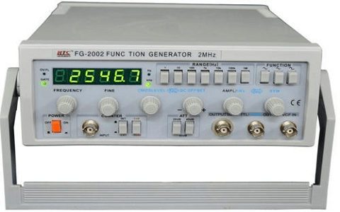

**Fig : Function** **Generator**

* + 1. **Motivation:**

The function generator is a unit which can be used to test the circuits with different input wave forms. & Functions

1. Sine wave
2. Square wave
3. Triangle wave
4. Saw tooth wave
5. sweep function

This is very useful instrument as development Aid/testing equipment in the design evaluation of circuits for various requirements…

1. create clock signals to digital circuits.

7. test communication circuits.

8. generate signals to send to integrator or differentiation circuits to test their outputs.

9. send pulses to circuits to trigger events.

10. vary pulse widths (PWM) to control a motor’s speed.

11. You are working on implementing a new standard. It uses PAM8. Although your company's transmitter won't even be sent out for Fab for 9 months, you need to be

designing the receiver and testing prototype versions before that, or you'll delay the project. Where can you get a PAM8 signal before any transmitter exists? If you have an arbitrary

function generator, you can set it up to make it, probably within a day or two of effort (depends on the pattern you need).

12. You are trying to test an FM radio receiver. You don't have any specialized test equipment, but you do have a handy function generator. Set it to generate FM cantered at somewhere between 88 and 108 MHz Based on modulation frequency, you can test frequency response. Modulation amplitude lets you test bandwidth, and Max amplitude. O.K. that should be sufficient.

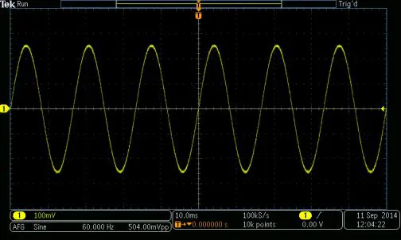

**Sine Wave in Oscilloscope**

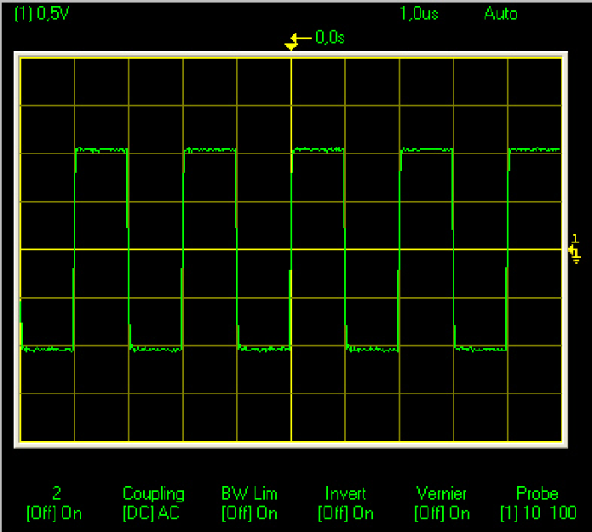

**Square Wave in Oscilloscope**

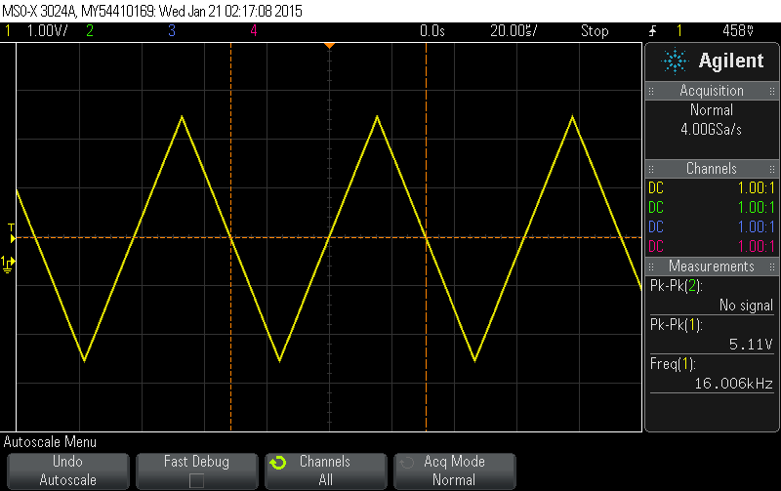

**Triangular Wave in Oscilloscope**

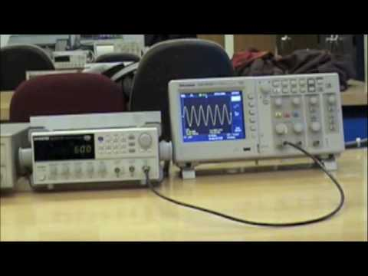

**Function Generator & It’s waveform in Osciloscope**

**Hardware required for the Project**

For this particular project we need:

1. ICL8038
2. OP-AMP (IC741)
3. Potentiometer (1kΩ, 10kΩ)
4. Diode1N457
5. Capacitor (10 µF, 0.1 µF, 0.005 µF, 100 pF)
6. Arduino Nano
7. 16X2 LCD Display
8. Transformer (220V – 12V)
9. IC7812
10. IC7912
11. LED
12. Jumper wires (Male to Female)
13. Bread Board
14. Resistor ( 4.7 kΩ, 100 kΩ, 470 kΩ, 50 kΩ)

**Hardware Description**

1. **ICL-8083**:

**Introduction**: The ICL8038 waveform generator was an Integrated circuit by Intersil designed to generate sine, square and triangular waveforms,[1] based on bipolar monolithic technology involving Schottky barrier diodes. ICL8038 was a voltage-controlled oscillator434 capable of producing frequencies between a millihertz and 100 kHz.

Triangular waves were produced by charging and discharging a capacitor with constant currents. The triangular waves were converted to sine waves involving a non-linear network.[4]: 4  The output frequency was set either by resistors or the external control voltage.[4]: 6  The temperature drift could be optimized to less than 250ppm/°C by combining it with a PLL.

**Uses:** The ICL8038 is a function generator chip, capable of generating triangular, square, sine, pulse, and sawtooth waveforms. From this sine, square & triangular waveforms can be made simultaneously. There is an option to control the parameters like frequency, duty cycle, and distortion of these functions. The ICL8038 is a function generator chip, capable of generating triangular, square , sine, pulse and sawtooth waveforms . From these sine, square & triangular wave forms can be made simultaneously. There is an option to control the parameters like frequency, duty cycle and distortion of these functions.

**Pin diagram and its work:** The ICL8038 is a function generator chip, capable of generating triangular, square , sine, pulse and sawtooth waveforms . From these sine,

square & triangular wave forms can be made simultaneously. There is an option to control the parameters like frequency, duty cycle and distortion of these functions

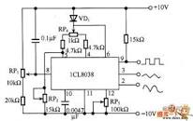  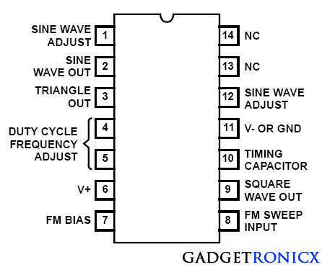

**2. OP-AMP (IC741):**

The 741 Op Amp IC is a monolithic integrated circuit comprising ageneral-purpose erational Amplifier. It was first manufactured by Fairchild semiconductors in the year 1963. The number 741 indicates that this operational amplifier IC has 7 functional pins, 4 pins capable of taking input, and 1 output pin.

**Pin diagram and its work :**

**Power Supply Pins: Pin 4 and 7**

Pin 4 and pin 7 are the negative and positive voltage power supply terminals. The power which is required for the IC to function is received from both these pins. The voltage level between these pins can be in the range of 5 – 18V.

**Output Pin: Pin 6**

The output which is delivered from the IC 741 op amp is received from this pin. The output voltage that is received at this pin is based on the feedback approach that is used and the voltage level at the input pins.

When the voltage value at pin 6 is high, this corresponds that output voltage is similar to the +ve supply voltage. In the same way, when the voltage value at pin 6 is low, this corresponds that output voltage is similar to the -ve supply voltage.

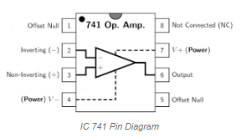

**4. Diode 1N457:**

**Introduction:** These small low capacitance diodes with very fast switching speeds are hermetically sealed and bonded into a double-plug DO-35 package. They may be used in a variety of fast switching applications. Microsemi also offers a variety of other switching/signal diodes.

**Uses:** The **1N457** is a high conductance small Signal **Diode** for general **use** and also suitable for many different **applications**. Low leakage; 500mW Power dissipation; 300° ...

**Work:** The 1N457 is a high conductance small Signal Diode for general use and also suitable for many different applications. Low leakage; 500mW Power dissipation; 300°

The factory should be consulted on applications involving pulsed or low duty cycle operations. Thermal Characteristics. DO-35. Colour Band Denotes Cathode.

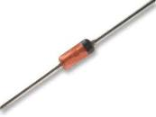

**5.Capacitor:**

**Introduction:** The capacitor is the basic electronic component that is used for storing, surge suppression and filtering. It is a widely used and important component in the family of electronics. Like resistor, capacitors are passive components to store an electric charge.

**Uses:** Capacitors have many uses in electronic and electrical systems. They are so ubiquitous that it is rare that an electrical product does not include at least one for some purpose.  
...  
**Contents**

* Energy storage.
* Pulsed power and weapons.
* Power conditioning.
* Power factor correction.
* Suppression and coupling.

**Work**: A capacitor is a device that is used to store charges in an electrical circuit. A capacitor works on the principle that the capacitance of a conductor increases appreciably when an earthed conductor is brought near it. Hence, a capacitor has two plates separated by a distance having equal and opposite charges.

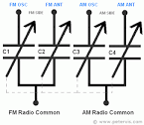

**8.Transformer(220v-12v):**

**Introduction:** A transformer is one of the most common devices found in electrical system that links the circuits which are operating at different voltages .These are commonly used in applications where there is a need of AC voltage conversion from one voltage level to another.

It is possible either to decrease or increase the voltage and currents by the use of transformer in AC circuits based on the requirements of the electrical equipment or device or load. Various applications use wide variety of transformers including power, instrumentation and pulse transformers.

In a broad, transformers are categorized into two types, namely, electronic transformers and power transformers. Electronic transformers operating voltages are very low and are rated at low power levels. These are used in consumer [electronic equipment’s](https://www.electronicshub.org/basic-electronic-components/) like televisions, personal computers, CD/DVD players, and other devices.

The term power transformer is referred to the transformers with high power and voltage ratings. These are extensively used in power generation, transmission, distribution and utility systems to

increase or decrease the voltage levels. However, the operation involved in these two types of transformers is same. So let us go in detail about the transformers.

**Uses:** Transformers are employed for widely varying purposes; e.g., to reduce the voltage of conventional power circuits to operate low-voltage devices, such as doorbells and toy electric trains, and to raise the voltage from electric generators so that electric power can be transmitted over long distances.

**Working:** The operation of the transformer is based on the principle of mutual induction between two coils or winding which are linked by a common magnetic flux. When the primary winding is energized with AC source supply, a magnetic flux is established in the primary winding.

This flux is linked with both primary and secondary windings because the core provides a low reluctance path for the magnetic flux. Hence, most of the flux produced by the primary winding links with the secondary winding. This is called as main flux or useful flux. And also, the flux which does not link with the secondary winding is called as leakage flux. Most of the transformers are designed to have low leakage flux to reduce the losses.

According to the Faraday’s laws of electromagnetic induction, this flux linkage with both primary and secondary windings induces EMFs in them. This EMF induced in each winding is proportional to the number of turns in it. The voltage or EMF induced in the primary winding is called as back EMF which opposes the input supply voltage to the extent that no primary current would flow.

But small magnetizing current flows through the primary of the transformer. The EMF induced in the secondary winding is the open circuit voltage. If the secondary circuit is closed or the load is connected, secondary current starts flowing through it which causes to create demagnetizing magnetic flux. Due to this demagnetizing flux, the unbalance is created between the applied voltage and back EMF.

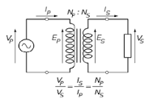

**9.IC7812:**

**Introduction:** The ic 7812 is a positive voltage regulator which means that itgenerates the positive voltage with respect to the common ground. In case if both the positive and negative voltage supply is needed in the same circuit. The voltage regulator ic 7812 is combined with its corresponding 79XX family IC that is 7912 IC.

**Pin diagram and its work:** The 7812 is a commonly used linear regulator. Input voltage canrange from 14 – 35VDC and it outputs a fixed 12V at over 1A of current and up to 2.2A **of** surge

current. For basic operation, no external components are required. Just hook up the input voltage and ground and you have 5V available on the output.

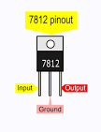

**10. IC7912:**

**Introduction:** This is the IC 7912. 79xx voltage regulators are very commonly used in electronic circuits. The main purpose of this IC is to supply required regulatednegative voltage to the circuits.  
...  
79xx ICs and Output Voltages.

|  |  |
| --- | --- |
| **IC Number** | **Output Voltage** |
| 7905 | -05 Volts |
| 7912 | -12 Volts |
| 7915 | -15 Volts |
| 7918 | -18 Volts |

**Pin diagram and its work:** This is the IC 7912. 79xx voltage regulators are very commonly used in electronic circuits. The main purpose of this IC is to supply required regulatednegative voltage

to the circuits. IC 79xx can supply a constant negative voltage output, in spite of any voltage fluctuations in its input voltage.

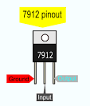

1. **Resistor:**

**Introduction:** A resistor is a component that resists the flow of electricity. This flow of electricity is called current. Each resistor has a value that tells how strongly it resists current flow. This resistance value is called the ohm, and the sign for the ohm is the Greek letter omega:

**Uses:** A resistor is a passive two-terminal electrical component that implements electrical resistance as a circuit element. In electronic circuits, resistors are used to reduce current flow, adjust signal levels, to divide voltages, bias active elements, and terminatetransmission lines, among other uses. A resistor works by restricting the flow of current, it can do this in one of three ways: firstly, by using a less conductive material, secondly by making the conductive material thinner and finally by making the conductive material longer.

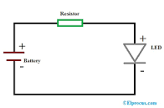

**6. Arduino Nano:**

**Introduction:** Arduino Nano is a small, complete, flexible and breadboard-friendly Microcontroller board, based on ATmega328p, developed by Arduino.cc in Italy in 2008 and contains 30 male I/O headers, configured in a DIP30 style. Arduino Nano Pinout contains 14 digital pins, 8 analog Pins, 2 Reset Pins & 6 Power Pins.

**Uses**: It is used to produce a clock of precise frequency using constant voltage. There is one limitation of using Arduino Nano i.e. it doesn't come with a DC power jack, which means you cannot supply an external power source through a battery.

**Pin diagram and its work**: Arduino is an open-source electronics platform based on easy-to-use hardware and software. Arduino boards are able to read inputs - light on a sensor, a finger on a button, or a Twitter message - and turn it into an output - activating a motor, turning on an LED, publishing something online.

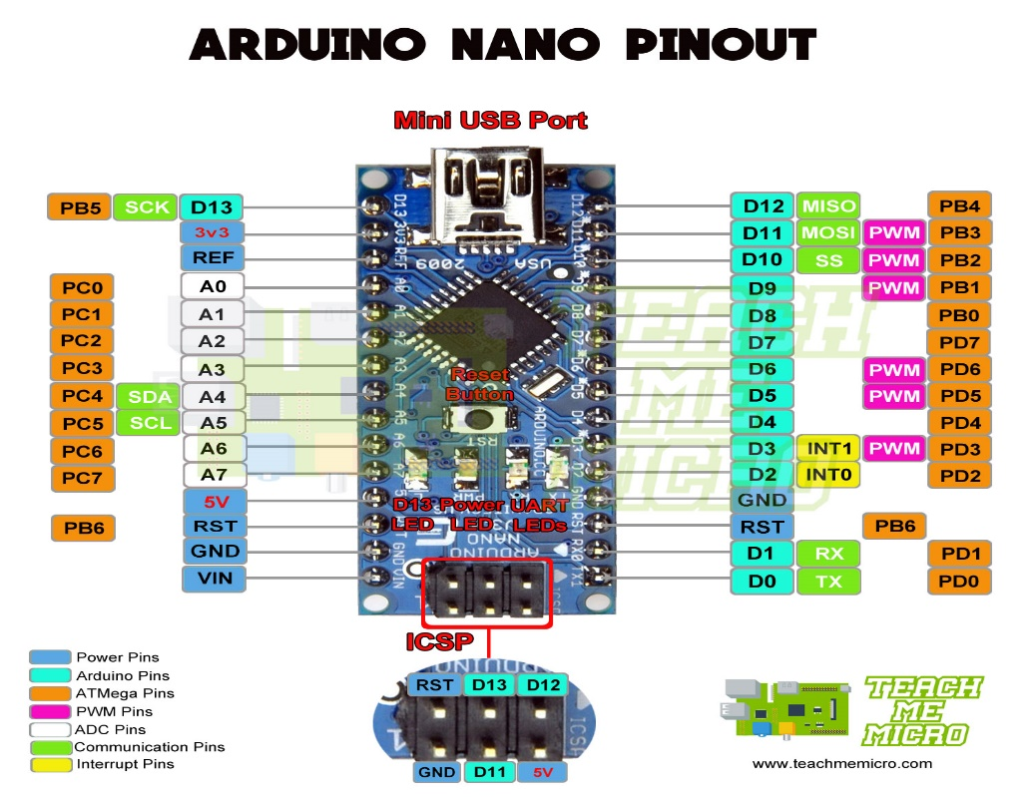

**CIRCUIT DIAGRAM**

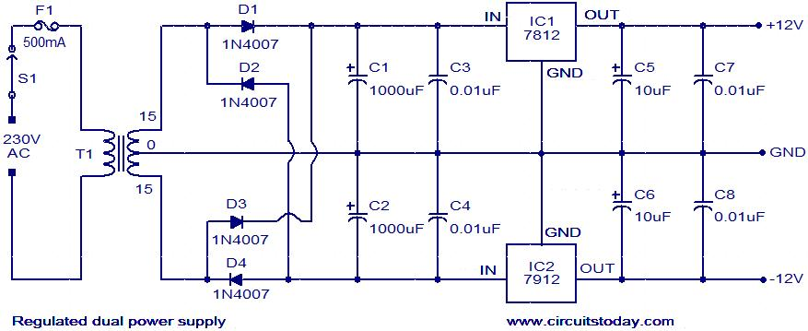

**Fig -** **12V Power Supply using 7812 & 7912**

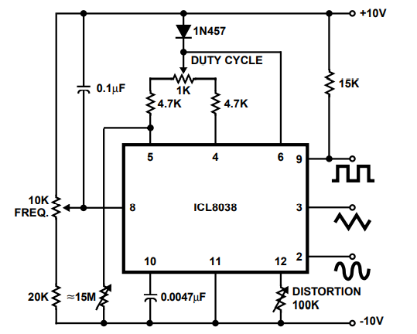

+12V

-12V

**Fig – ICL8038 Circuit Diagram**

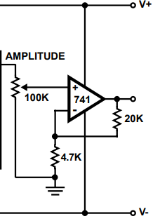

**Fig - Amplitude controlling circuit using OP-AMP 741**

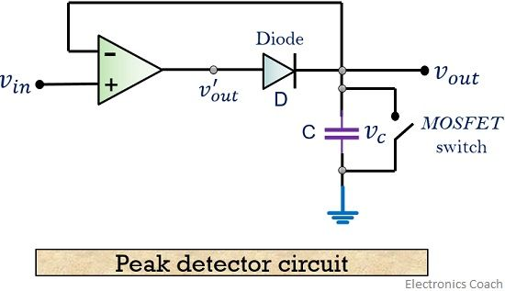

**Fig – Peak Detector circuit**

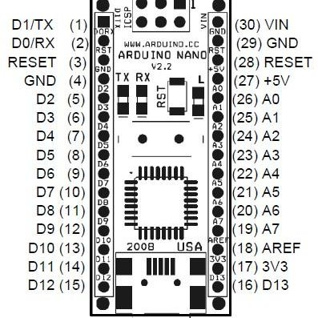

**Fig : Arduino Nano Pin** **diagram**

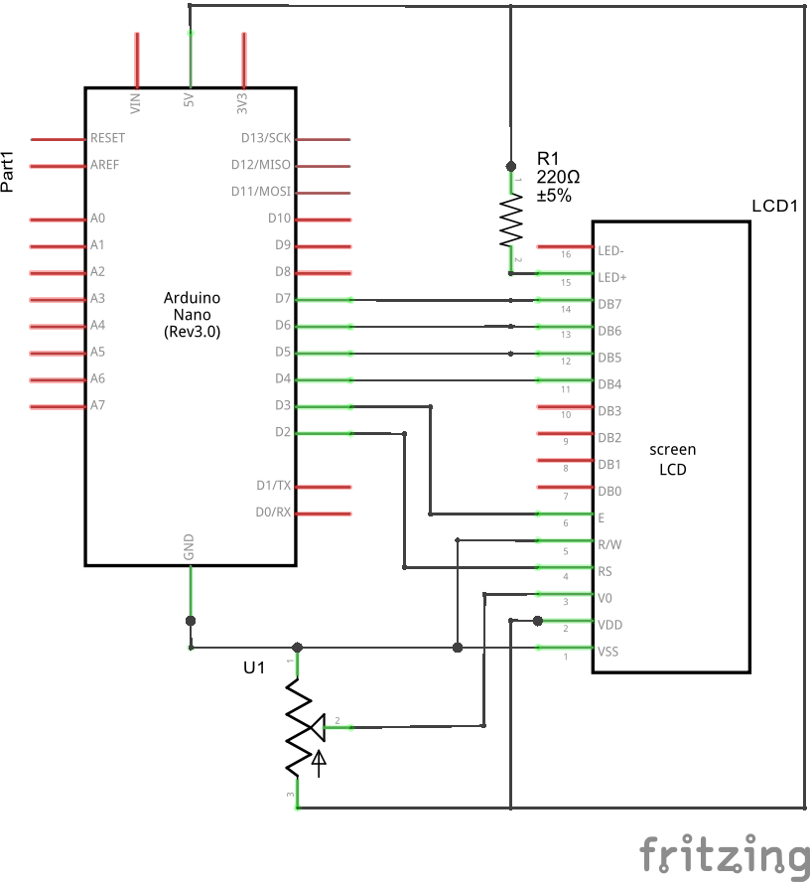

**Fig : Arduino Nano to LCD display circuit diagram**

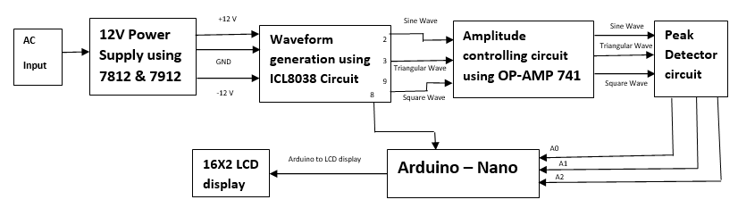

**Fig : Circuit Diagram Using Block Representation**

**SYSTEM IMPLEMENTATION**

* **12 V Power Supply using IC7812 & 7912**:

This is a +/- 12v dual power supply circuit diagram using 7812 and 7912. We use an LM7812 voltage regulator IC for +12V and LM7912 for -12V. This circuit is suitable for a preamplifier tone control with an OP-AMP circuit. It can deliver an output current of not more than 1A.I will show you, an interesting concept. When we build a small preamplifier circuit. It needs to use a power supply. It requires a low supply current is only 100mA. But It is special that the need for dual voltage in three terminals positive, negative, and ground. So, we use a 12V dual power supply. **+/- 12V dual power supply circuit**. In the circuit, There is an unregulated power supply. Which include S1, F1, T1, D1, D2, C1, C2, C3, and

C4. Since they are two rectifier diodes in half-wave rectifier form. You should use the double filter capacitors, C2 and C4. To reduce a ripple voltage.

This circuit uses a 300mA transformer AC 15V CT 15V. (30V) When it converts to DCV. This voltage rises up to about 42VDC.  Each input voltage is 21VDC comes to  7812 and 7912. Both IC-regulator keeps a constant voltage to the output.

Other parts working.

* IC1-IC2 do not need to hold the heat sinks because of the very low currents.
* C5, C6 are the filter capacitors to reduce ripple signal.
* C7 cleans the transient voltage to the output.
* LED1 is an indicator of Power ON. And R1 is the **current limiter** of LED1.
* C1, C2, C3, C4 are the **filter capacitors** to smooth DC pulse to DC stable voltage.  If you have them a lot. They are good.

If you want 12V dual power supply that higher current more than 500mA. This circuit is good for you.

In the circuit, it is similar to the above circuit. But they change some components as follows.

* Change the current size of a transformer of 1A secondary coil.
  + Using Full wave rectifier diodes is better. They have 4 diodes, 1N4007.
  + So, You can use two filter capacitors. But there is a higher current than above.
  + C3, C4, C7 and C4 filter capacitors to clean transient voltage from input.
  + Also, C5 and C6 capacitor filtered the ripple voltage to the output.
  + LED1 shows power on using a limiting current resistor.
* **Waveform generation using ICL8038:**

The ICL8038 is a function generator chip, capable of generating triangular, square, sine, pulse and sawtooth waveforms. From these sine, square & triangular wave forms can be made simultaneously. There is an option to control the parameters like frequency, duty

cycle and distortion of these functions. This is the best function generator circuit for a beginner to start with and is of course a must on the work bench of an electronics

hobbyist. The circuit here is designed to produce waveforms from 20Hz to 20 kHz. The ICL 8038 has to be operated from a dual power supply.

* The circuit needs a [**dual power supply**](https://www.circuitstoday.com/dual-power-supply-using-l165). A +12 -12 power supply as shown in the circuit is enough for the purpose.
* The frequency of the output wave form can be adjusted using R7. It must be a 100K Log POT.
* The duty cycle can be adjusted using R3, a 1K POT.
* The distortion of the wave form can be adjusted using R5, a 100K POT.
* Square, Triangle & Sine waveforms can be obtained simultaneously at pins 9,3,2 respectively.
* **Amplitude controlling circuit using OP-AMP 741:**

**Power Supply Pins: Pin 4 and 7**

Pin 4 and pin 7 are the negative and positive voltage power supply terminals. The power which is required for the IC to function is received from both these pins. The voltage level between these pins can be in the range of 5 – 18V.

**Output Pin: Pin 6**

The output which is delivered from the IC 741 op amp is received from this pin. The output voltage that is received at this pin is based on the feedback approach that is used and the voltage level at the input pins.

When the voltage value at pin 6 is high, this corresponds that output voltage is similar to the +ve supply voltage. In the same way, when the voltage value at pin 6 is low, this corresponds that output voltage is similar to the -ve supply voltage.

**Input Pins: Pin 2 and Pin 3**

These are the input pins for the operational amplifier. Pin 3 is considered as the inverting input while pin 3 is considered as the non-inverting input pin. When the voltage value at pin 2 >> pin 3 which means that inverting input has a high value of voltage, then the output signal is low.

In the same way, when the voltage value at pin 3 >> pin 2 which means that non- inverting input has a high value of voltage, then the output signal is high.

**Offset Null Pins: Pin 1 and Pin 5**

As before discussed, this operational amplifier has an increased level of voltage gain. Because of this, even minimal variations in the voltages at both non-inverting and inverting inputs those are happened because of the abnormalities in the constructional procedure or other anomaly’s will show an impact on the output.

In order to overcome this, an offset value of the voltage to be applied at pin 1 and pin 5, and this generally accomplished by a potentiometer.

**Not Connected Pin: Pin 8**

It is just a pin that is used to fill up the empty pin in the IC 741 Op Amp. It has no connection with any of the internal or external circuits.

* **Peak Detector circuit:**

The working principle of the circuit is such that, the peak of the input waveform is followed and stored in terms of voltage in the capacitor.

By the time on moving further, if the circuit detects a higher peak, the new peak value is stored in the capacitor until it is discharged. The working principle of this circuit is that the peak of the input waveform is followed and stored in terms of voltage (Vc) across the capacitor.

Whenever the input voltage is greater than the capacitor voltage Vc, the diode D will be ON and there will be the charging of the capacitor C. The circuit will be working as a non-inverting amplifier and capacitor voltage V, follows input voltage Vi

Whenever the input voltage is greater than the capacitor voltage Vc, the diode D will be ON and there will be the charging of the capacitor C. The circuit will be working as a non-inverting amplifier and capacitor voltage V, follows input voltage Vi.

Whenever the input voltage Vi is lesser than the capacitor voltage Vc, the diode D will be OFF and the op-amp is working in an open-loop configuration. In this case, capacitor voltage Vc holds its previous maximum charged voltage until the input voltage Vi becomes more than this maximum voltage.

The capacitor employed in the circuit is charged through the diode by the applied input signal. The small voltage drop across the diode is ignored and the capacitor is charged up to the highest peak of the applied input signal.

Let us consider initially the **capacitor** is charged to voltage**Vc**. The diode employed in the circuit gets forward biased when the applied **input voltage Vin** exceeds the capacitor voltage**Vc**. Thereby allowing the circuit to behave as a **voltage follower**. The output voltage follows the applied input voltage until Vin is more than Vc.

As the input voltage Vin reduces below the value of capacitive voltage Vc, it causes the diode to get reverse biased. In such condition, the capacitor retains the value until the input again exceeds the value stored in the capacitor.

The figure below shows the output voltage waveform for an applied input signal

As we can see in the waveform shown above, at time t1, the circuit misses the peak of the input signal as it is less than the previous peak of the input signal. Thereby allowing the capacitor to hold the value of the previously occurred peak.

As it is a positive peak detector, one can also construct a negative peak detector circuit, that will hold the lowest or most negative signal voltage. This is basically done by**reversing** the **polarities** of the diode in the circuit.

* **Analog amplitude measurement using Arduino:**

Probably a simple peak detector input stage, as shown in figure, could work. When a pulse signal with amplitude Vin is injected,  
the capacitor connected to analog pin 0 maintains a voltage (Vin-0.7) Volt until it is

discharged. This is done through the resistor connected  
to digital pin 8. The sequence to be programmed on Arduino should be:

1. set pinMode(D8, INPUT), this sets high impedance input avoiding capacitor discharge;
2. measure the pulse peak by calling analogRead(A0) at a low rate
3. when done discharge the capacitor by setting pinMode(D8, OUTPUT); digitalWrite(D8, LOW).

16X2

LCD

display

A0

Arduino

Nano

**-**

**+**

**Peak Detector**

* **Arduino Nano to LCD display circuit diagram :**

Before wiring the LCD screen to your Arduino board we suggest to solder a pin header strip to the 14 (or 16) pin count connector of the LCD screen, as you can see in the image further up.

To wire your LCD screen to your board, connect the following pins:

* LCD RS pin to digital pin 12
* LCD Enable pin to digital pin 11
* LCD D4 pin to digital pin 5
* LCD D5 pin to digital pin 4
* LCD D6 pin to digital pin 3
* LCD D7 pin to digital pin 2
* LCD R/W pin to GND
* LCD VSS pin to GND
* LCD VCC pin to 5V
* LCD LED+ to 5V through a 220 ohm resistor
* LCD LED- to GND

Additionally, wire a 10k potentiometer to +5V and GND, with it's wiper (output) to LCD screens VO pin (pin3).

**PROGRAMMING CODE**

* **For frequency and amplitude (Square wave):**

/* Square wave's peak detector output connected to pin A0

* Square wave's output connected to pin 8

*/

#include <LiquidCrystal.h>

#define pulse_ip 8

LiquidCrystal lcd(7, 6, 5, 4, 3, 2);

int adc_val, on_time, off_time;

float volt, freq, period, fact = 0.00488;

void setup(){

lcd.begin(16, 2);

lcd.setCursor(0,0);

lcd.print("AMP :");

lcd.setCursor(0,1);

lcd.print("FREQ:");

}

void loop() {

/* For Amplitude Calculation */

adc_val = analogRead(A0);

volt = (float) (fact * adc_val);

lcd.setCursor(6,0);

lcd.print(volt*2);

/* For Frequency Calcultion */

on_time = pulseIn(pulse_ip, HIGH);

off_time = pulseIn(pulse_ip, LOW);

period = on_time + off_time;

freq = 1000000/period; // period is in microsec, freq is in Hz

lcd.setCursor(6,1);

lcd.print(freq);

delay(200);

}

* **For Amplitude (Sine wave):**

/* Sine wave's peak detector output connected to pin A1

#include <LiquidCrystal.h>

LiquidCrystal lcd(7, 6, 5, 4, 3, 2);

int adc_val,;

float volt, period, fact = 0.00488;

void setup(){

lcd.begin(16, 2);

lcd.setCursor(0,0);

lcd.print("AMP :");

lcd.setCursor(0,1);

lcd.print("FREQ:");

}

void loop() {

/* For Amplitude Calculation */

adc_val = analogRead(A1);

volt = (float) (fact * adc_val);

lcd.setCursor(6,0);

lcd.print(volt);

* **For Amplitude (Triangular wave):**

/* Triangular wave's peak detector output connected to pin A2

#include <LiquidCrystal.h>

LiquidCrystal lcd(7, 6, 5, 4, 3, 2);

int adc_val,;

float volt, period, fact = 0.00488;

void setup(){

lcd.begin(16, 2);

lcd.setCursor(0,0);

lcd.print("AMP :");

lcd.setCursor(0,1);

lcd.print("FREQ:");

}

void loop() {

/* For Amplitude Calculation */

adc_val = analogRead(A1);

volt = (float) (fact * adc_val);

lcd.setCursor(6,0);

lcd.print(volt*(7/5));

**RESULT ANALYSIS**

* **Power Source generation using 7812 & 7912:**

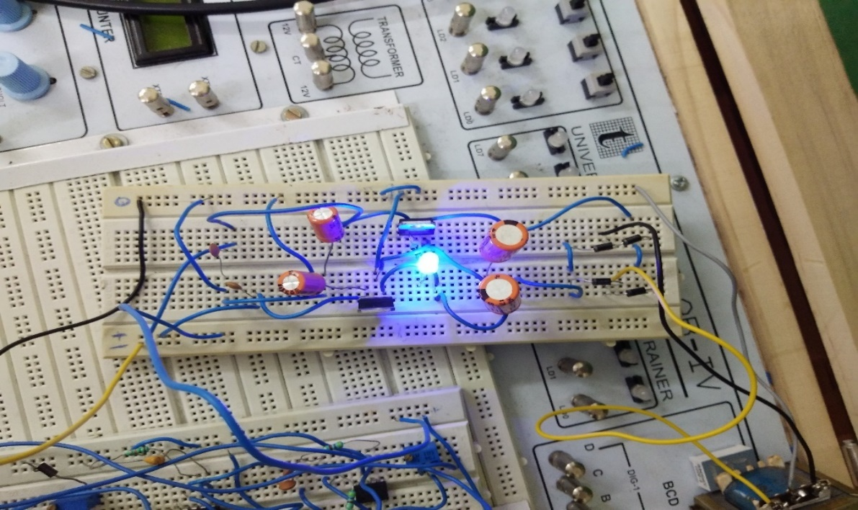

* **ICL8038 Circuit :**

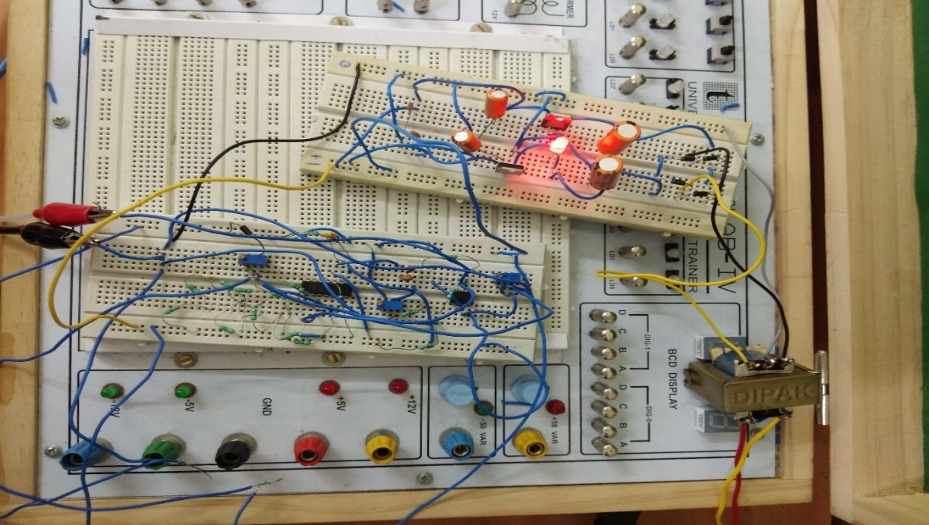

* **Peak Detector Circuit:**

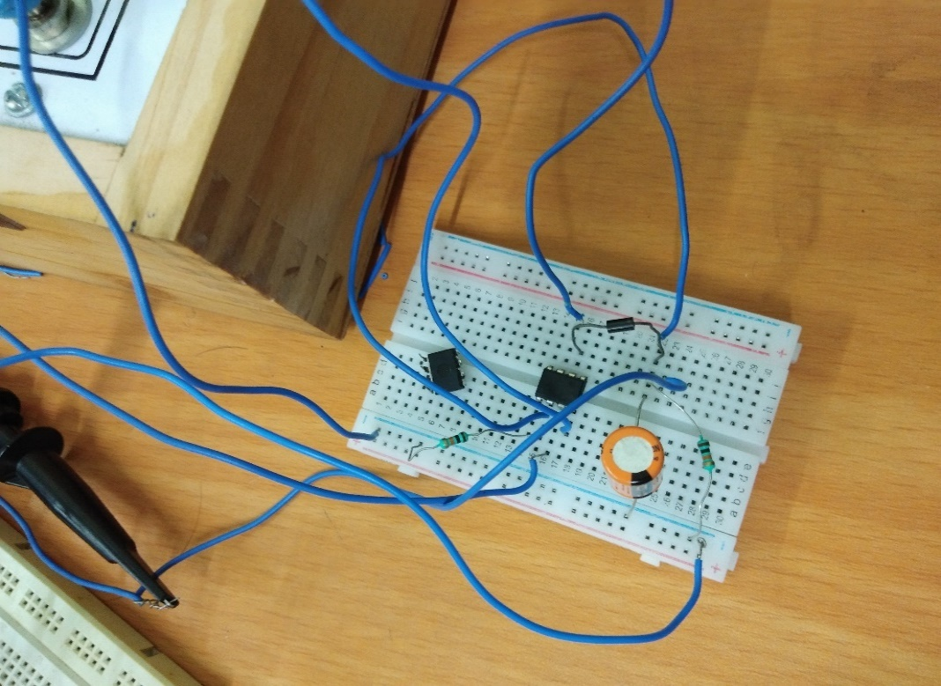

* **Peak Detector to Arduino:**

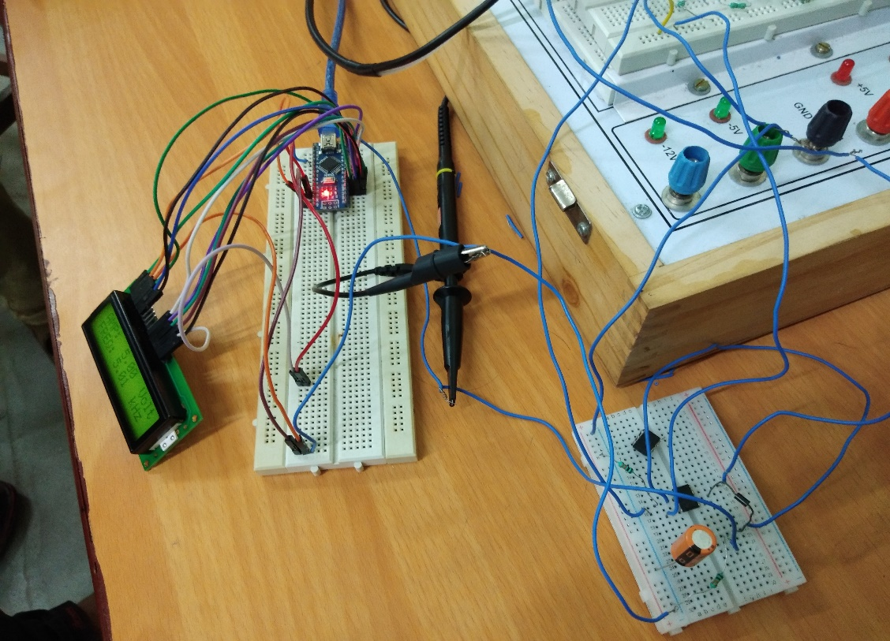

* **Arduino to 16X2 display connection:**

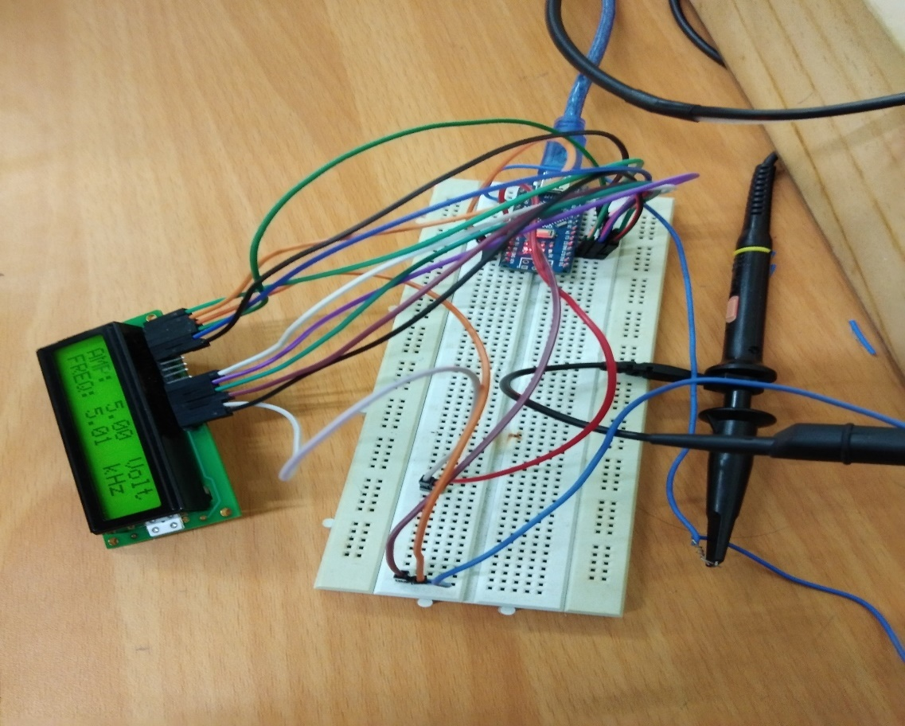

* **16X2 Display Amplitude & frequency:**

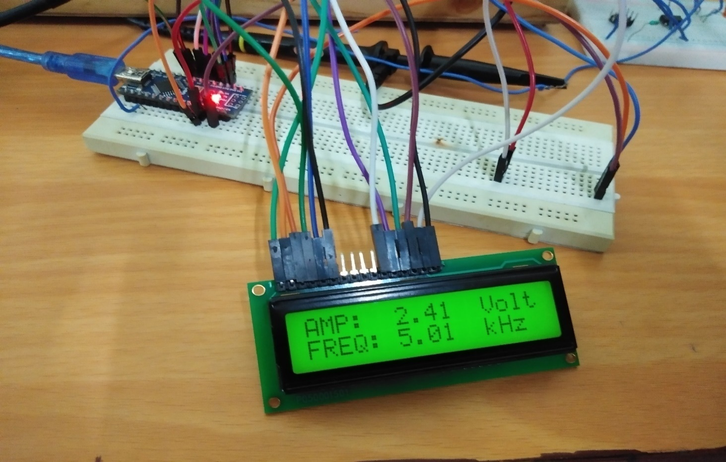

* **Sine Wave:**

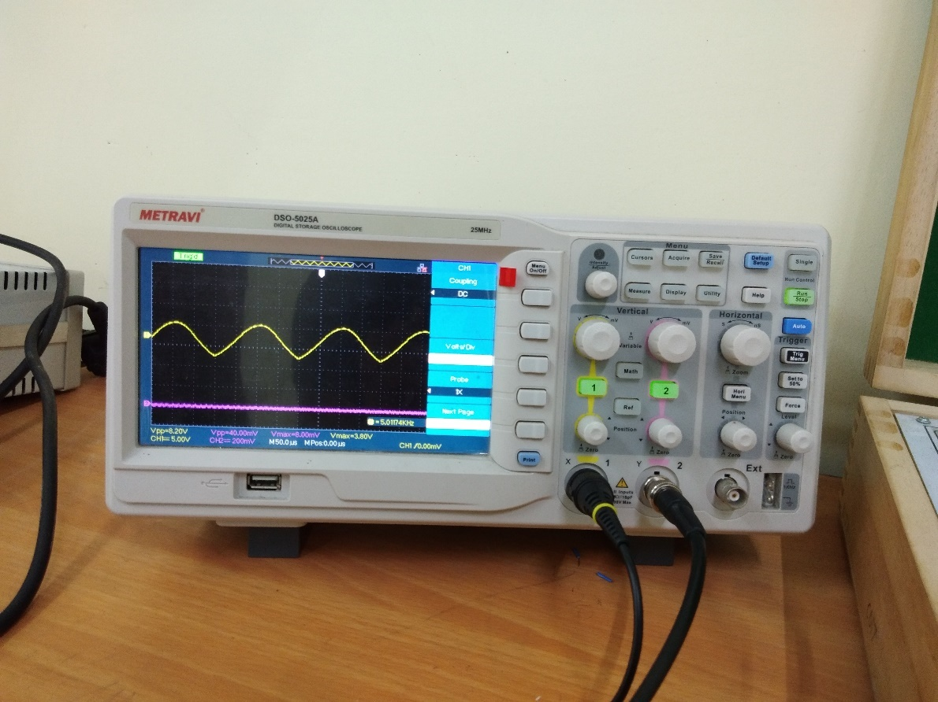

* **Triangular Wave:**

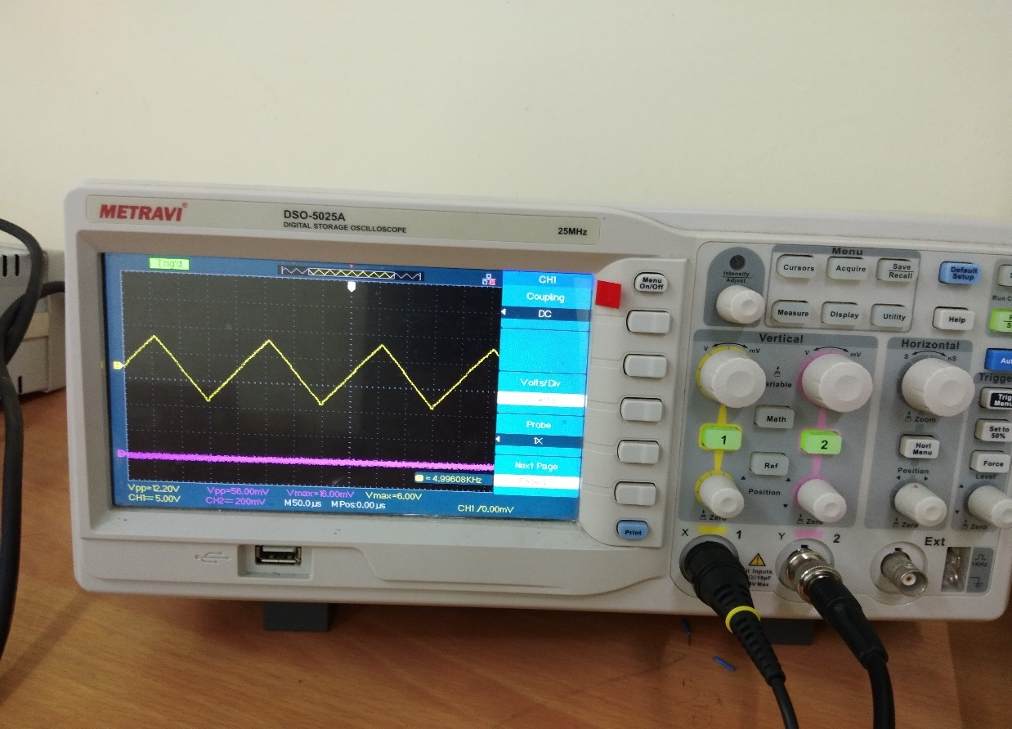

* **Square Wave:**

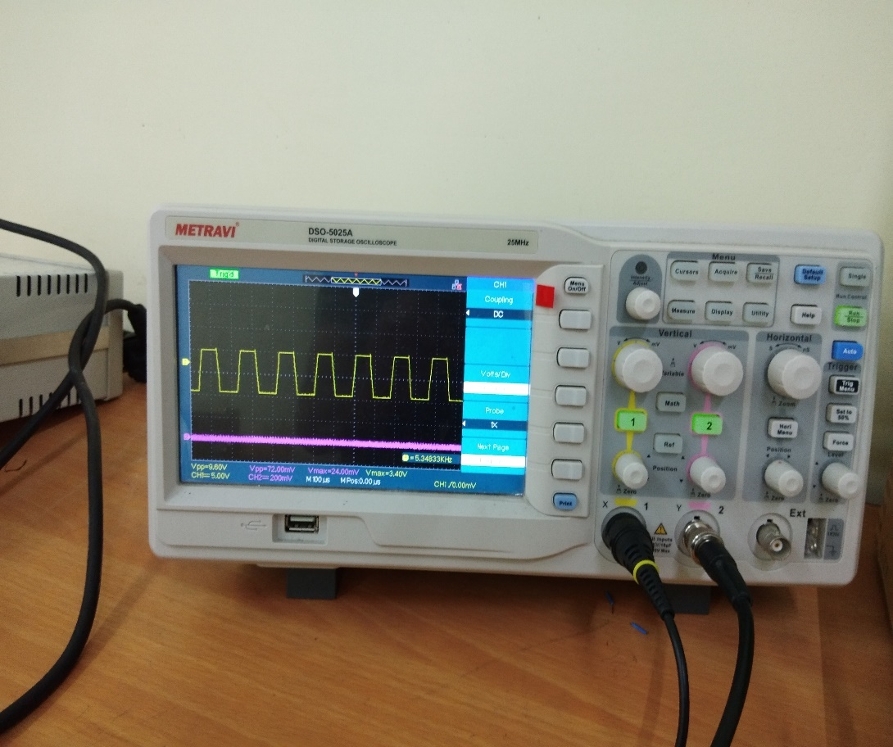

**References**

* <https://en.wikipedia.org/wiki/Arduino_Nano>
* <https://www.mit.edu/~6.331/icl8038data.pdf>
* <https://www.elprocus.com/ic-741-op-amp-tutorial-and-characteristics/>
* ICL8038 DATA SHEET